

**Faculty of engineering - Shoubra**

**Benha University**

|  |  |  |  |
| --- | --- | --- | --- |
|  | Name | Edu mail | B.N |
| 1 | **حسن خالد حسن عبدالغني سويلم** | **hasan195325@feng.bu.edu.eg** | **294** |

**TOBIC: Programming languages**

* **Application Brief:**

This application addresses programming languages that used to communicate with a computer and give it a set of tasks to do, and there is a list of programming languages such as C and C++ which are considered to be programming languages of the middle level. Given the abstraction that is done to the code to keep it understandable and easy to use for programmers, this has little to no cost when it comes to performance and efficiency which greatly affects high-level programming languages. We may say programming language is the language of the future because it has many applications that will support us in our lives.

* SCREEN SHOTS:

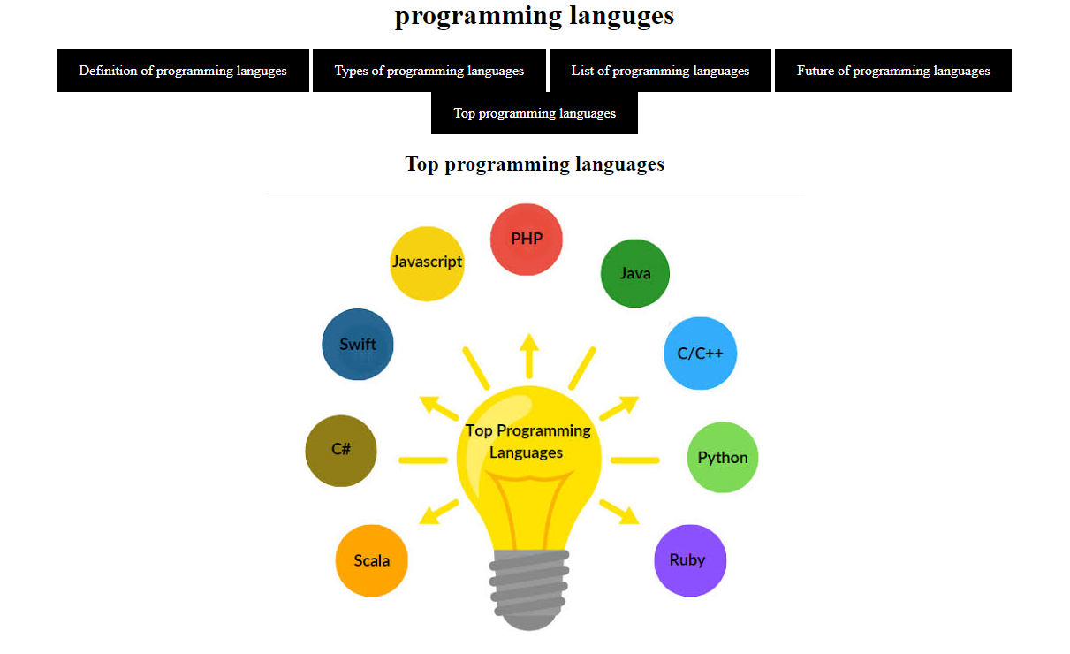

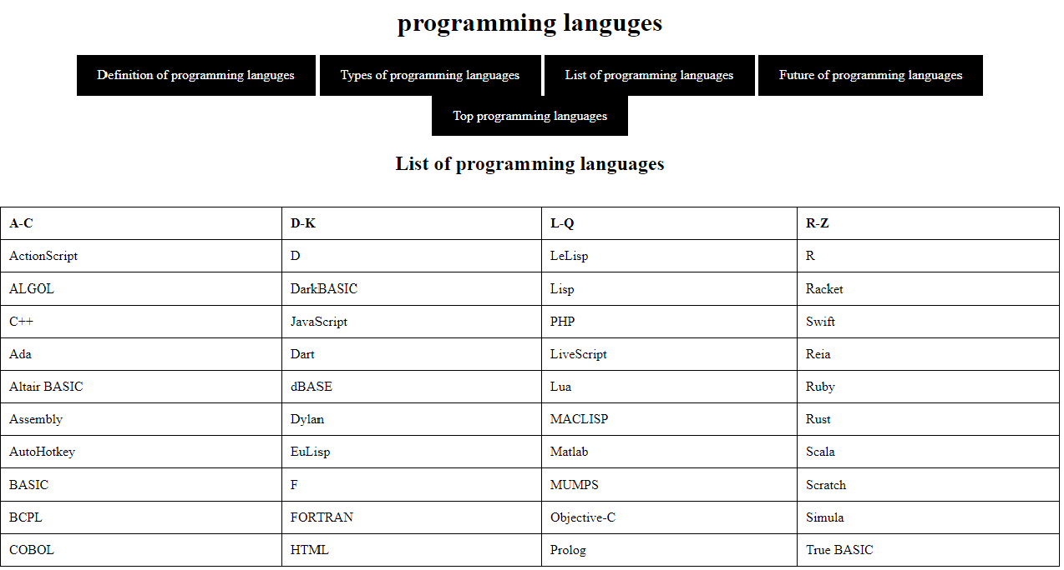

* **Resource code :**



